Post the paper bid in Georgia Procurement Registry(GPR)
Step # | Action
1 | Login to GPR. Link: https://ssl.doas.state.ga.us/PRSapp/PR_login.jsp
2 | To post the paper bid Main Menu> Click ‘Bid Processing’ under ‘Posting Bid Notices and Documents’> ‘Post a Bid’  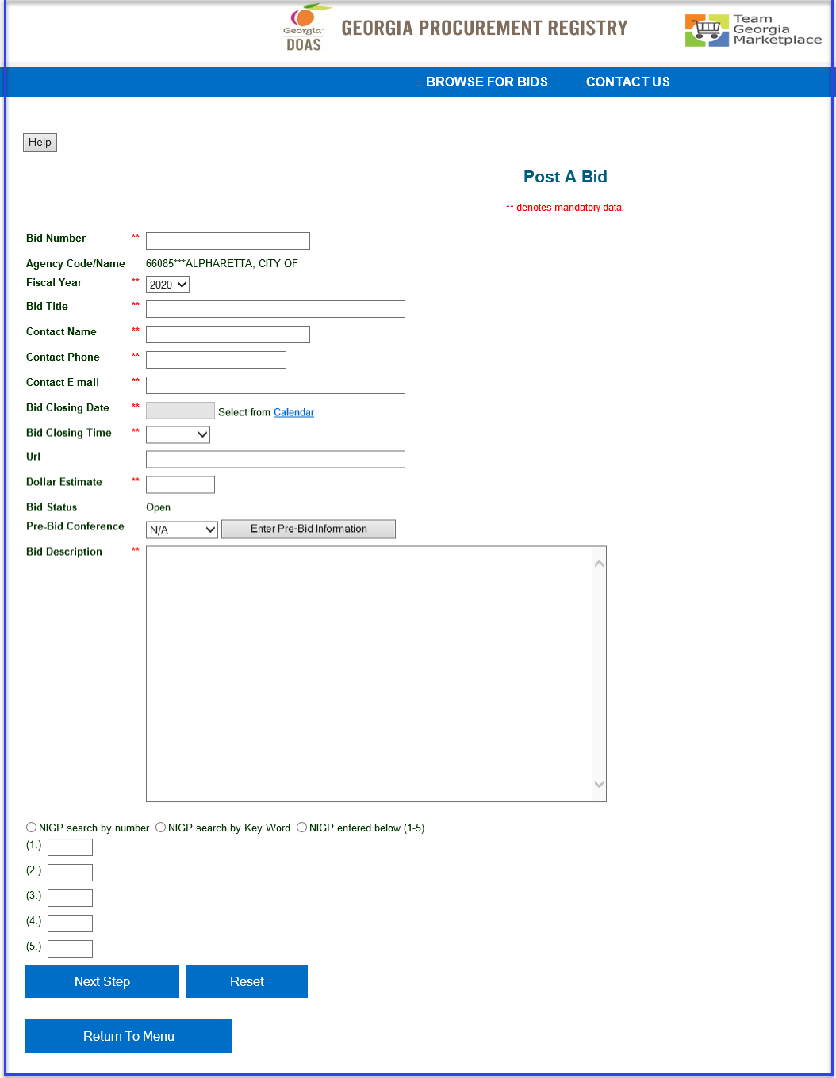
3 | Enter all the required fields.  - Bid number, Fiscal Year are key elements which cannot be altered once the bid is posted.  - Bid Number is Unique Identifier and cannot be repeated once used.  - Agency Code/ Name are pre-populated as per the user’s login. User is responsible to validate the ‘Agency Name’ before posting the bid.  - Buyer can provide the URL for the bid on their own agency site.  - Enter estimated dollar amount for the bid.  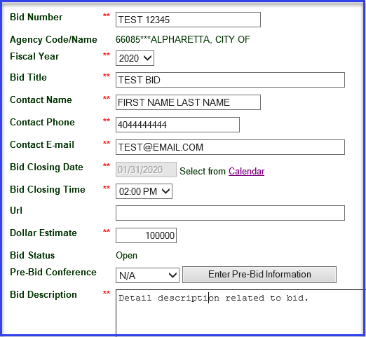
4 | Select the option for Pre-Bid conference if there is any and provide conference details. (*Pre-bid conferences cannot be scheduled during the last Seven calendar days before bid opening.)  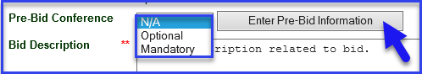  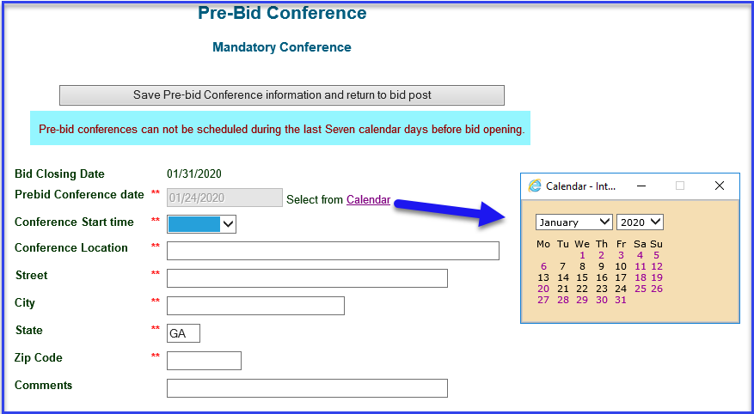
5 | Enter detail description (Character limitation < 2000 characters)
6 | Select any option to enter the NIGP Code. (* Codes can be entered manually If you have the codes handy and are <= 5.) Click ‘Next Step’.  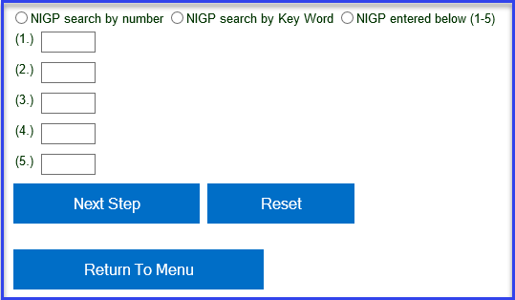
7 | If option selected is NIGP search by key Word, then enter the key word for NIGP Codes.  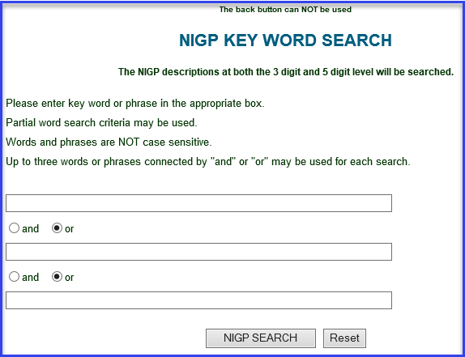
8 | Select appropriate NIGP code/s.  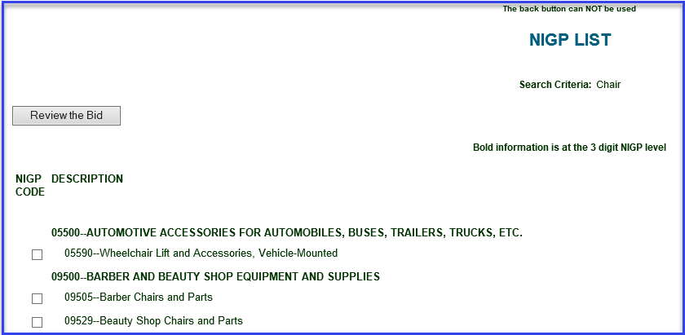
9 | Click on ‘Reassign NIGP Codes ‘to update the NIGP Codes. (**NIGP codes cannot be edited once bid posts.)  Click ‘Check This Form’ to let system check the bid information. Click on ‘Post the Bid’ to post the bid. System will notify if error/s found.  To cancel click on ‘Return To Menu’- this will not post a bid.
10 | Buyer will get the on-screen confirmation of bid posted. All suppliers registered for selected NIGP codes will be notified via email.  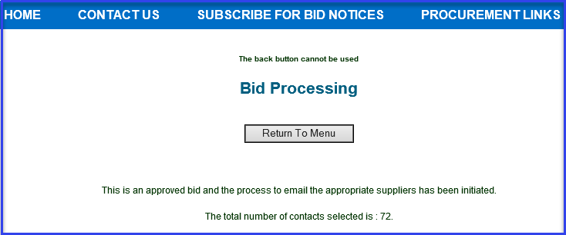  Click on ‘Return To Menu’ to go back to Main Menu.  Refer to ‘Upload attachments in GPR’ guide to upload any attachment/s to the bid.
 | END

